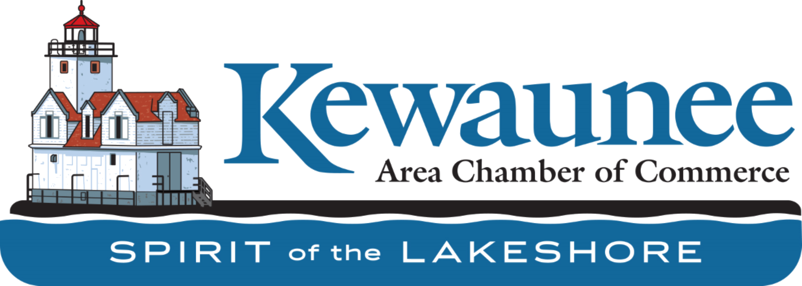

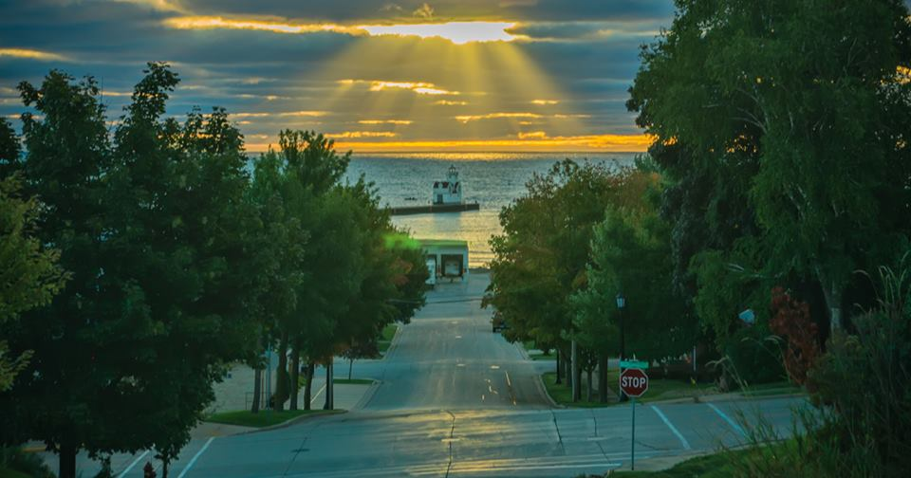
Greetings Chamber Members!  Thank you for being members of the Kewaunee Area Chamber of Commerce. Our Mission is “To provide the leadership necessary to promote Kewaunee’s tourism, business, and industrial development while preserving its maritime heritage.” | Kewaunee.org  Send us your events to get added to the calendar on our website!  Send us an email with all your details or call Renae at 920-388-4822. |  | Volunteers Needed  We urgently need volunteers to staff our center this summer!  We are planning for a busy tourism summer in Kewaunee! Spread the word or call to sign up for a time slot!
Make sure to follow us on Facebook and Instagram:
Kewaunee Area Chamber of Commerce | Facebook

KACC (@kewauneeareachamberofcommerce) • Instagram photos and videos

Welcome to the Chamber! Join us in welcoming our two newest members!

Bay Lake ATV Club, Kewaunee ATV Park

Lakeshore Life & Style

Save the Dates!
May/June Events!

**For more details on the events below go to www.kewaunee.org

A huge THANK YOU to our sponsors for the carp tournament coming up this weekend!! We are not able to put on events without your support and generosity!

Heyrman Printing
Carter’s Collison
Lakehave Hall
TEAM CLEAN
Holy Rosary
Lighthouse Title
Vollrath
Harbor Express
MAGIC
Pretty Please Boutique
The Bucket
Wakker Dairy
Kewaunee Custard
Coho Motel

May 28th – 11:00am – 12:00pm Yoga in the Vineyard – Door 44
**event runs weekly at same time through summer

May 28- 3:00pm – 6:00pm music by the vines – door 44
*event runs weekly at same time through summer

May 29- 10:00am – 1:00pm Garden CLub Plant sale

may 29 – 11:00am – 12:00pm yoga in the vineyard – parallel 44 and 12:00pm-3:00 Mimosas and music
**event runs weekly at same time through summer

may 30 – 12:00pm – 3:00pm mimosas and music – door 44
**event runs weekly at same time through summer

June 3rd-5th, 2021 Norman General Store – 3-year anniversary! Come for cake, popcorn, samples and sales! www.normangeneralstore.com

June 4th-5th – the rusty coop vintage barn market

June 11-12- Kewaunee Citywide Rummage Sale – forms are available now to list your sale on our website and lists will be out at local banks, the Chamber, the piggly wiggly and on our website and facebook.

June 20th - Breakfast on the Farm

june 20th – Car show at waterfront bar & grill

june 20th – 6:00pm – 8:30pm music in the park – adam trask band

june 26th-27th – times of future past event at winter park

june 27th – 6:009pm-8:30pm music in the park – safe sex

Hope to see everyone at our July 3rd event this year!
11:00 AM Food and beverages will be served until dusk! Food by
Muskrat City.
3:00 PM Kids activities will start
4:00 PM Blind Ambition will play until Dusk
Fireworks at Dusk

Do you need the 2021 guides? Let us know and we would love to stop in and drop some off!
